YooZit + iFincert
Installation, password creation and member login
Simple Android instructions for society members
Quick route
1 Install and open YooZit
2 Tap Profile, then the ⚙ Settings icon
3 In Profile Settings, tap iFincert
4 Tap Create password
5 Verify the OTP and save a password
6 Select society and financial year, then log in

Before you start
Keep the mobile phone registered with your society nearby. The OTP is sent to that registered number. Never share your OTP or password with anyone.
Screens may look slightly different after an app update, but the button names and order remain the same.

1 | Install YooZit  Use the Google Play Store on your Android phone.
- Open Google Play Store.
- Search for “YooZit”. Choose the app published by CERT Technology.
- Tap Install. When installation finishes, tap Open.
- If asked, sign in or create your YooZit account using your mobile number.
Direct Google Play link: YooZit – CERT Technology

Scan the QR code with the phone camera, or use the Play Store search.

2 | Open Settings, then iFincert  The iFincert member area is available inside YooZit Profile Settings.
- Open YooZit and tap Profile at the bottom-right.
- Tap the ⚙ Settings icon at the top-right of your profile.
- On the Profile Settings page, scroll if required and tap iFincert.
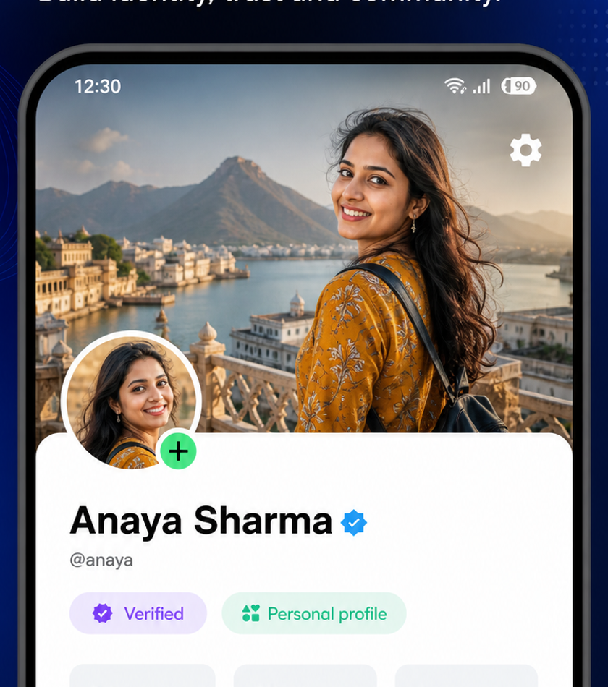 | 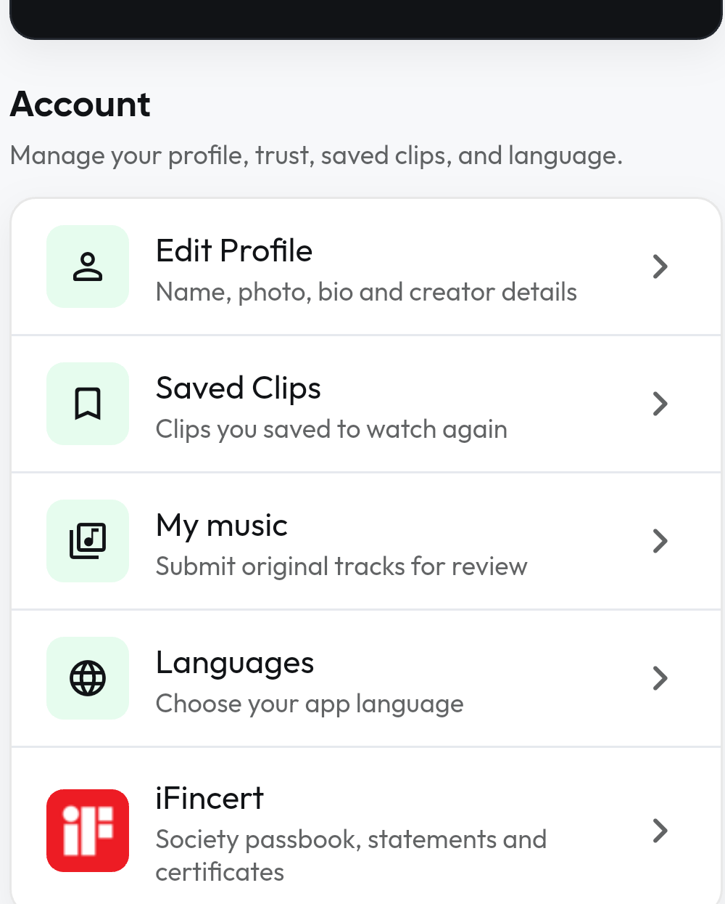
A. Tap the Settings gear | B. Tap iFincert
Tip
If iFincert is not visible, scroll down within Profile Settings.

3 | Create your iFincert password  First-time members use the registered mobile number to verify ownership.
- On Member login, tap Create password.
- Select your Society / Department.
- Enter the mobile number registered in your society membership record.
- Tap Continue.
- Tap Send verification code. Enter the 6-digit OTP, then tap Verify and continue.
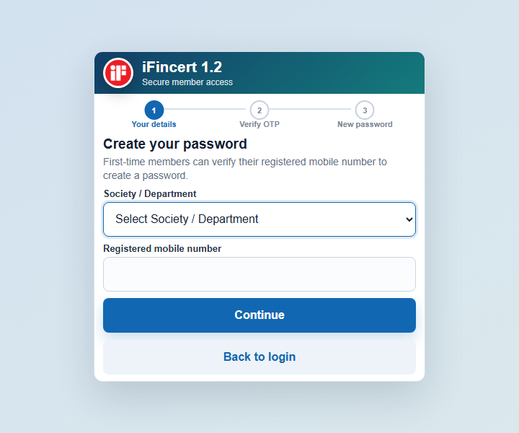 | 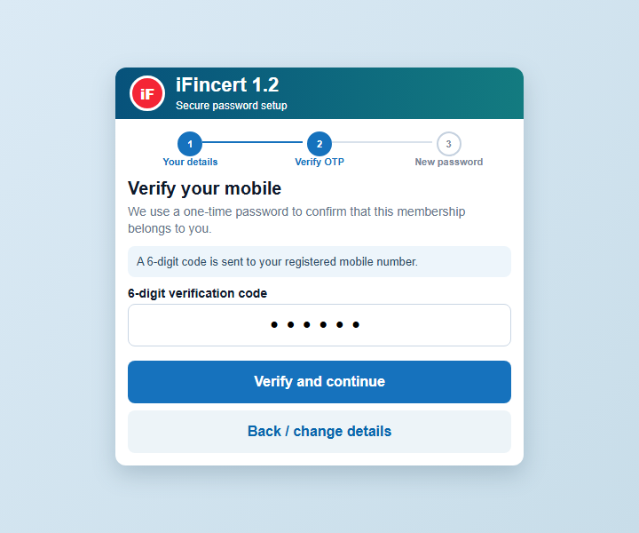
A. Enter society and registered mobile | B. Enter the 6-digit OTP
OTP not received?
Check the selected society and registered mobile number. Wait for the resend timer, then use Resend verification code. Contact the society office if the registered number is outdated.

4 | Save the password and log in  Use a unique password with at least 10 characters.
- Enter the new password, then enter the same password again in Confirm new password.
- Tap Save password. After the confirmation message, return to Member login.
- Select your Society / Department and Financial year.
- Enter the registered mobile number and the new password.
- Tap Login.
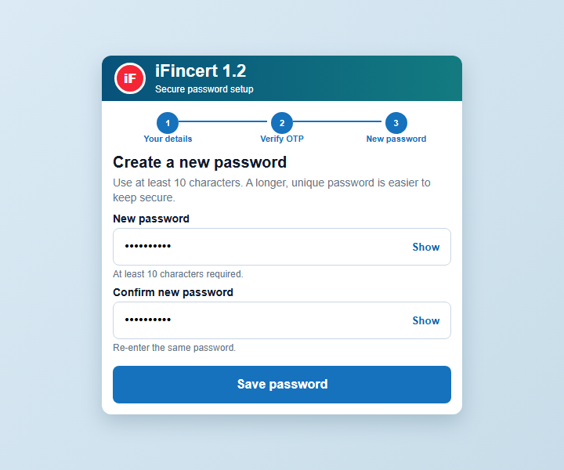 | 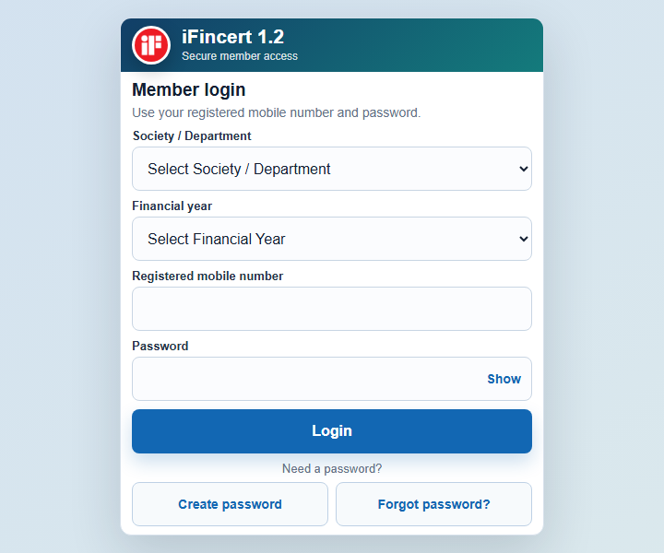
A. Create and save the password | B. Select details and log in
Safe password habits
Use a unique password. Do not share your OTP or password. If you forget it, tap Forgot password? on the Member login screen and repeat the OTP process.

